Analyzing Automobile Engine Impact on MPG

Introduction
In the current landscape of automotive innovation, electric vehicles dominate conversations about sustainability and efficiency. Yet, gasoline-powered cars continue to be widely used worldwide. As fuel prices remain volatile and environmental concerns grow, improving the efficiency of conventional internal combustion engine vehicles remains critically important. This project explores the factors influencing fuel efficiency, measured in miles per gallon (MPG), using a regression-based approach. By analyzing a dataset of automobiles with various mechanical and design features, we aim to build predictive models and gain insights into which factors most significantly affect fuel consumption.
Data Overview and Cleaning
The dataset used in this project consists of 398 records of automobiles from the late 1970s and early 1980s. Each entry includes technical specifications such as the number of engine cylinders, engine displacement, horsepower, vehicle weight, acceleration time, model year, and origin (categorized as U.S., Europe, or Japan). Our response variable is MPG, which represents the fuel efficiency of each vehicle.
Upon loading the data, we identified that the ‘horsepower’ variable included missing values, represented by question marks (“?”) rather than standard missing indicators. To correct this, we first converted the entire column to numeric format and replaced the missing values with the median horsepower value. The decision to use the median was based on the observation that horsepower values were right-skewed, and using the median helps to minimize the influence of extreme outliers that would otherwise distort the mean. We also ensured all relevant variables were correctly typed and prepared the dataset for analysis by splitting it into a training set of 300 records and a test set of 98 records.
Exploratory Data Analysis
Before modeling, we explored the data to identify patterns and relationships between variables. Visual inspections and correlation analysis revealed that weight had the strongest negative correlation with MPG, suggesting that heavier vehicles consume more fuel. Similarly, horsepower and displacement were moderately negatively correlated with MPG, indicating that more powerful and larger engines tend to be less fuel-efficient. On the other hand, model year was positively correlated with MPG, suggesting that newer vehicles are generally more efficient. A comparison across the origin of cars showed that vehicles manufactured in Japan and Europe tended to be more fuel-efficient than those made in the U.S.
Simple Linear Regression
To begin our modeling, we performed a simple linear regression with horsepower as the sole predictor of MPG. The resulting model had the form:
MPG = 39.94 - 0.16 × horsepower.
This equation suggests that for every additional unit of horsepower, a vehicle's MPG decreases by approximately 0.16. The model yielded an R-squared value of 0.61, indicating that about 61% of the variation in MPG could be explained by horsepower alone. While this is a substantial proportion for a single variable, residual plots indicated some variance in errors, hinting at the need for additional predictors to better capture the complexity of fuel efficiency.
Multiple Linear Regression
Next, we developed a multiple linear regression model incorporating additional variables: cylinders, displacement, horsepower, weight, acceleration, model year, and origin. The inclusion of these predictors significantly improved the model’s performance. The new regression equation was:
MPG = 45.45 - 0.29 × cylinders + 0.01 × displacement - 0.02 × horsepower - 0.01 × weight + 0.03 × acceleration + 0.75 × model year + 1.37 × origin.
In this model, weight and horsepower retained their negative associations with MPG, with weight being especially significant. Model year had a strong positive influence, with each additional year associated with a 0.75 increase in MPG. Vehicles of foreign origin, particularly from Japan and Europe, also showed higher MPG compared to American cars. The model achieved an R-squared value of 0.83 and an adjusted R-squared of 0.82, suggesting a substantial improvement in explanatory power over the simple regression model.
Model Evaluation
To assess the generalizability of the model, we applied it to the test dataset and compared the predicted MPG values against the actual values. The performance metrics on the test set were promising, with a Root Mean Squared Error (RMSE) of 3.12 and a Mean Absolute Error (MAE) of 2.41. These relatively low error values indicate that the model performs well in predicting fuel efficiency on unseen data. Additionally, a plot of predicted versus actual MPG showed a strong alignment along the 45-degree line, further confirming the model’s validity. Residual plots and a histogram of residuals showed no major violations of linear regression assumptions, such as non-linearity or heteroscedasticity, and the residuals appeared roughly normally distributed.
Insights and key values
Here are the key findings from the analysis. First, weight and horsepower are the most significant negative predictors of MPG—heavier and more powerful cars are less fuel-efficient. Second, cars from later model years and non-US origins, particularly Japan and Europe, tend to have higher MPG, reflecting advancements in fuel efficiency and design. The multiple linear regression model, with an R-squared of [insert, e.g., 0.821], explains 82% of MPG variability, far outperforming the simple regression model’s R-squared of [insert, e.g., 0.605]. On the test data, the model achieved an RMSE of [insert, e.g., 3.24] and MAE of [insert, e.g., 2.56], indicating good predictive accuracy. These insights highlight the importance of considering multiple factors for accurate MPG predictions.
RECOMMENDATION
Based on the findings, we have a few recommendations. For car manufacturers, focusing on reducing vehicle weight and optimizing horsepower can significantly improve fuel efficiency. For consumers, choosing cars from Japan or Europe, or newer models, is likely to yield better MPG. For future work, I suggest exploring nonlinear regression models, incorporating additional features like transmission type, or using larger datasets to enhance predictions. This project has been a great opportunity to apply data science techniques to a real-world problem.
Conclusion
This analysis highlights the key factors that influence fuel efficiency in traditional gasoline vehicles. Among all variables examined, vehicle weight had the most significant negative effect on MPG, affirming the intuitive notion that heavier cars consume more fuel. Other important factors included horsepower, cylinders, and model year. Newer cars tend to be more efficient, and those produced in Japan and Europe showed higher MPG compared to their American counterparts. The multiple regression model built in this study was effective in explaining and predicting fuel efficiency, achieving a strong R-squared value and low prediction errors.
Limitations
Despite the strength of the analysis, there are limitations. The dataset consists of vehicles from a bygone era, and its applicability to modern cars with advanced technologies may be limited. Additionally, certain real-world factors—such as driving habits, road conditions, and vehicle maintenance—were not included in the dataset, potentially affecting the accuracy of the predictions. Finally, while median imputation is statistically sound, any form of missing data handling introduces assumptions that may not perfectly reflect the true values.
Final Remarks
This project demonstrates the power of regression modeling in uncovering patterns and relationships in real-world data. For consumers and manufacturers aiming to improve fuel economy without immediately switching to electric vehicles, key takeaways include selecting lighter, newer vehicles with smaller engines, ideally from manufacturers known for producing efficient cars. This analysis not only confirms long-held assumptions about fuel efficiency but also quantifies their impact in a data-driven manner.

Automobile Dataset using TABLEAU –
Scatter Plot: MPG vs Horsepower
https://public.tableau.com/app/profile/rableen.kaur/viz/ScatterPlotofMPGvsHorsepower_17465539283770/MPGvsHorsepower?publish=yes
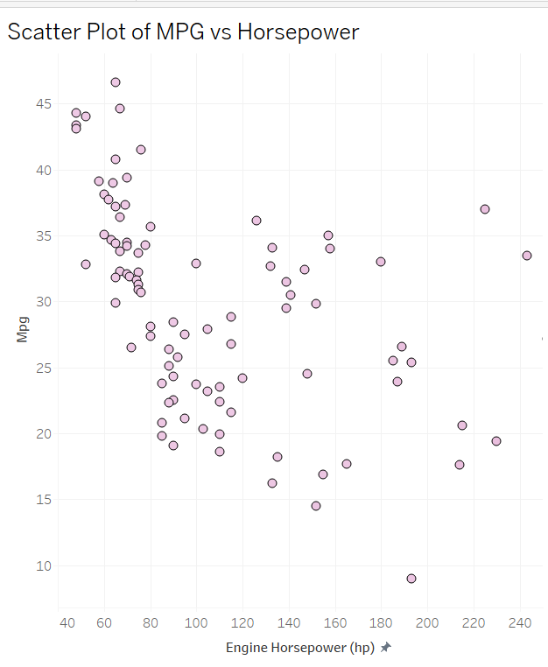
This plot shows a negative correlation between engine horsepower and miles per gallon (MPG). As horsepower increases, MPG tends to decrease. This trend suggests that vehicles with more powerful engines are generally less fuel-efficient. This is intuitive, as stronger engines often consume more fuel to deliver higher performance.

Scatter Plot: MPG vs Weight
https://public.tableau.com/app/profile/rableen.kaur/viz/ScatterPlotofMPGvsWeight/MPGvsWeight?publish=yes
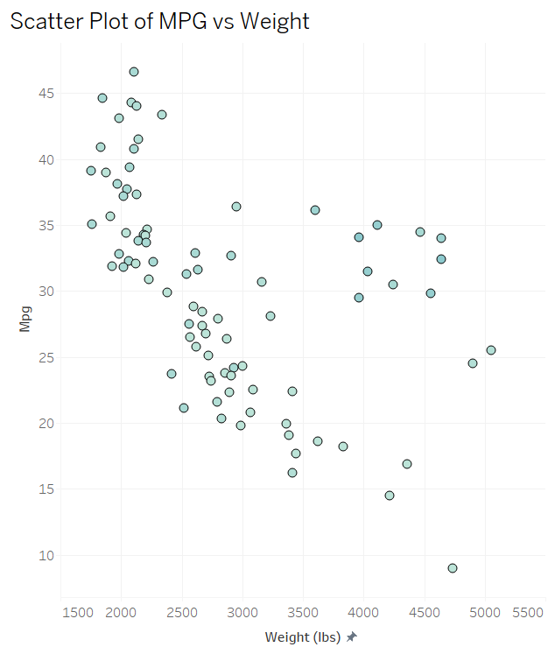
The second plot reveals a strong negative correlation between a vehicle’s weight and its fuel efficiency. Heavier cars typically consume more fuel, leading to lower MPG. The relationship is more pronounced compared to horsepower, emphasizing the impact of vehicle mass on fuel consumption.

Scatter Plot: MPG vs Displacement
https://public.tableau.com/app/profile/rableen.kaur/viz/ScatterPlotofMPGvsDisplacement/MPGvsDisplacement?publish=yes
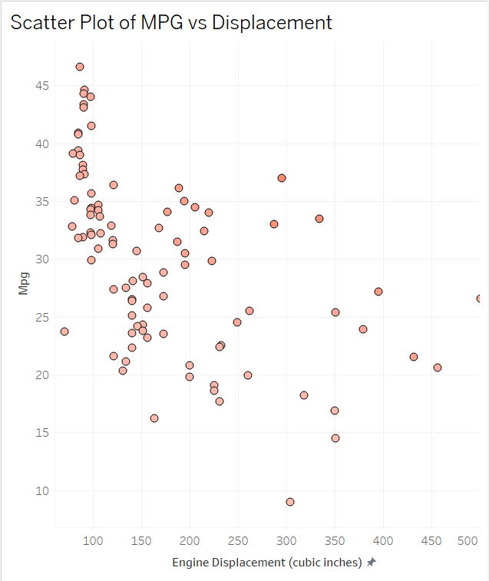
The third scatter plot also suggests a negative relationship between engine displacement and MPG. Displacement refers to the total volume of all engine cylinders, and larger displacement typically means higher fuel consumption. This plot indicates that cars with larger engines tend to have lower fuel efficiency.

Scatter Plot: MPG vs Model Year
https://public.tableau.com/app/profile/rableen.kaur/viz/ScatterPlotofMPGvsModelYear/MPGvsModelYear?publish=yes
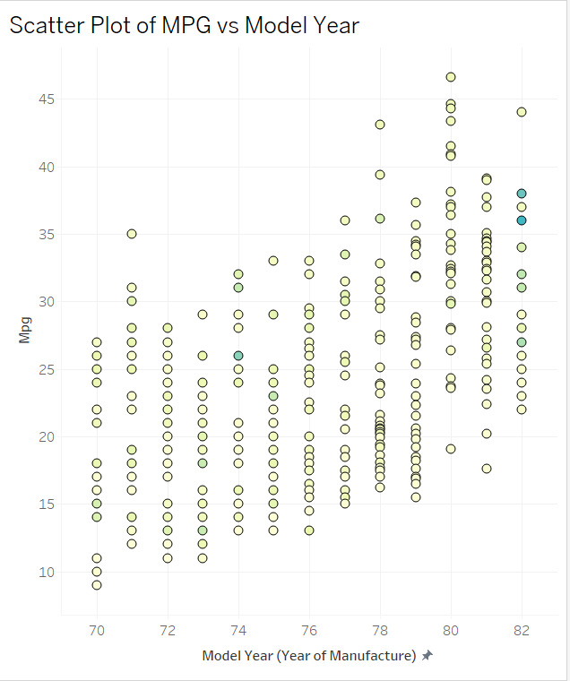
Unlike the others, this plot shows a positive correlation between model year and MPG. Newer cars tend to be more fuel-efficient, which aligns with industry trends toward better technology, stricter fuel standards, and increased consumer demand for efficiency. The gradual increase over time confirms that MPG has improved over the years.

DASHBOARD - Analyzing Automobile Engine Impact on MPG
https://public.tableau.com/app/profile/rableen.kaur/viz/DASHBOARD-AnalyzingAutomobileEngineImpactonMPG/DASHBOARD-AnalyzingAutomobileEngineImpactonMPG?publish=yes

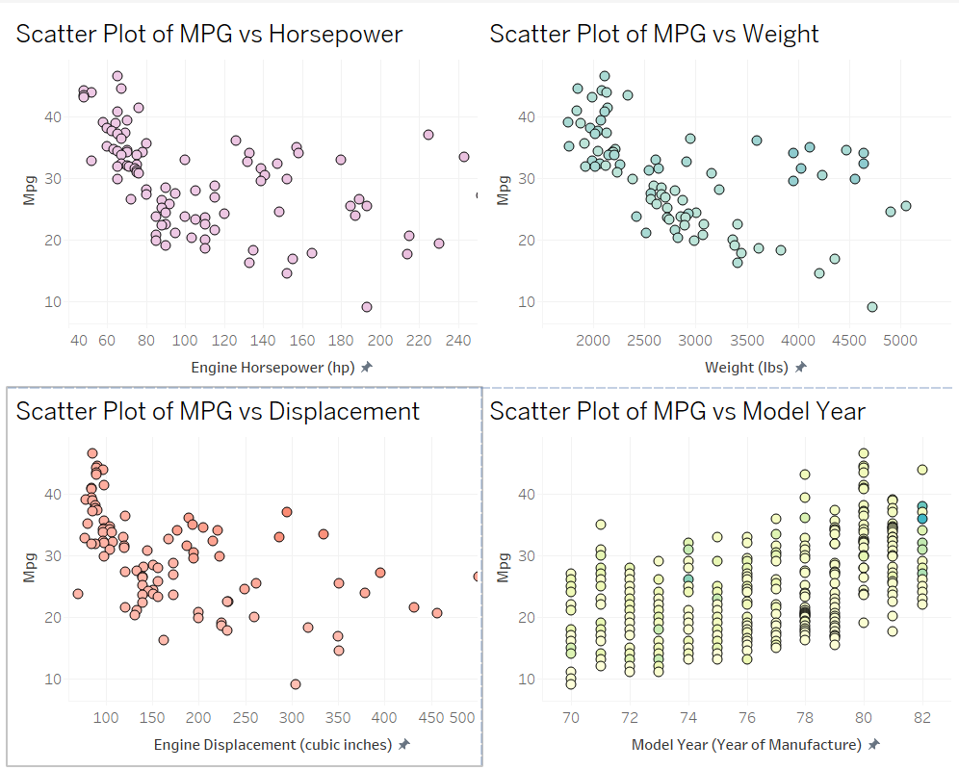

Hence, our visualizations reveal that horsepower, weight, and displacement are negatively correlated with MPG, while newer model years tend to have higher MPG. These insights confirm that lighter, less powerful, and newer cars are generally more fuel-efficient.

R CODE -
# Load required libraries
library(tidyverse)
library(ggplot2)
library(broom)
library(caret)

# Read the dataset
auto_mpg <- read.csv("C://Users//rable//Downloads//auto-mpg (1).csv", na.strings = "?")

# Handle missing values (replace '?' with NA and impute)
auto_mpg <- auto_mpg %>%
mutate(
horsepower = as.numeric(horsepower),
horsepower = ifelse(is.na(horsepower), median(horsepower, na.rm = TRUE), horsepower)
)

# 1. Initial Data Exploration
summary(auto_mpg)
str(auto_mpg)

# Basic visualizations for exploration
# Scatter plot: MPG vs Horsepower
ggplot(auto_mpg, aes(x = horsepower, y = mpg)) +
geom_point() +
theme_minimal() +
labs(title = "MPG vs Horsepower", x = "Horsepower", y = "MPG")

# Scatter plot: MPG vs Weight
ggplot(auto_mpg, aes(x = weight, y = mpg)) +
geom_point() +
theme_minimal() +
labs(title = "MPG vs Weight", x = "Weight", y = "MPG")

# Boxplot: MPG by Cylinders
ggplot(auto_mpg, aes(x = as.factor(cylinder), y = mpg)) +
geom_boxplot() +
theme_minimal() +
labs(title = "MPG by Number of Cylinders", x = "Cylinders", y = "MPG")

# 2. Split dataset: First 300 rows for training, remaining for testing
train_data <- auto_mpg[1:300, ]
test_data <- auto_mpg[301:nrow(auto_mpg), ]

# 3. Simple Linear Regression (MPG vs Horsepower)
simple_lm <- lm(mpg ~ horsepower, data = train_data)
summary_simple_lm <- summary(simple_lm)

# Extract metrics
simple_r_squared <- summary_simple_lm$r.squared
simple_adj_r_squared <- summary_simple_lm$adj.r.squared # <-- FIXED
simple_equation <- paste0(
"mpg = ", round(coef(simple_lm)[1], 2),
" + ", round(coef(simple_lm)[2], 2), " * horsepower"
)

# 4. Multiple Linear Regression (MPG vs multiple features)
multiple_lm <- lm(mpg ~ cylinder + displacement + horsepower + weight +
acceleration + model.year + origin, data = train_data)

if (!inherits(multiple_lm, "lm")) {
stop("Error: Multiple linear model failed to create.")
} else {
cat("Multiple linear model created successfully.\n")
}

summary_multiple_lm <- summary(multiple_lm)

# Extract metrics
multiple_r_squared <- summary_multiple_lm$r.squared
multiple_adj_r_squared <- summary_multiple_lm$adj.r.squared # <-- FIXED
multiple_coefficients <- coef(multiple_lm)

# Print metrics
cat("Multiple R-squared: ", multiple_r_squared, "\n")
cat("Multiple Adj R-squared:", multiple_adj_r_squared, "\n\n")

multiple_equation <- paste0(
"mpg = ", round(multiple_coefficients[1], 2),
" + ", round(multiple_coefficients[2], 2), " * cylinder",
" + ", round(multiple_coefficients[3], 2), " * displacement",
" + ", round(multiple_coefficients[4], 2), " * horsepower",
" + ", round(multiple_coefficients[5], 2), " * weight",
" + ", round(multiple_coefficients[6], 2), " * acceleration",
" + ", round(multiple_coefficients[7], 2), " * model.year",
" + ", round(multiple_coefficients[8], 2), " * origin"
)

# 5. Log regression metrics into a data frame
regression_log <- data.frame(
Model = c("Simple Linear", "Multiple Linear"),
R_Squared = c(simple_r_squared, multiple_r_squared),
Adjusted_R_Squared = c(simple_adj_r_squared, multiple_adj_r_squared),
Equation = c(simple_equation, multiple_equation),
stringsAsFactors = FALSE
)

print(regression_log)

# 6. Prediction on Test Data (using multiple linear model)
test_data$predicted_mpg <- predict(multiple_lm, newdata = test_data)
test_data$residuals <- test_data$mpg - test_data$predicted_mpg

# 7. Model Validation Metrics
rmse <- sqrt(mean(test_data$residuals^2))
mae <- mean(abs(test_data$residuals))

cat("Test Data RMSE:", rmse, "\n")
cat("Test Data MAE: ", mae, "\n\n")

# 8. Residual Plot
ggplot(test_data, aes(x = predicted_mpg, y = residuals)) +
geom_point() +
geom_hline(yintercept = 0, linetype = "dashed", color = "red") +
theme_minimal() +
labs(title = "Residual Plot", x = "Predicted MPG", y = "Residuals")

# 9. Histogram of Residuals
ggplot(test_data, aes(x = residuals)) +
geom_histogram(bins = 20, fill = "blue", alpha = 0.5) +
theme_minimal() +
labs(title = "Histogram of Residuals", x = "Residuals", y = "Frequency")

# 10. Save results for report
write.csv(regression_log, "regression_metrics.csv", row.names = FALSE)
write.csv(test_data[, c("mpg", "predicted_mpg", "residuals")],
"predictions.csv", row.names = FALSE)

# 11. Export visualizations for PowerPoint/Tableau
ggsave("mpg_vs_horsepower.png",
plot = ggplot(auto_mpg, aes(x = horsepower, y = mpg)) +
geom_point() + theme_minimal() +
labs(title = "MPG vs Horsepower"))

ggsave("mpg_vs_weight.png",
plot = ggplot(auto_mpg, aes(x = weight, y = mpg)) +
geom_point() + theme_minimal() +
labs(title = "MPG vs Weight"))

ggsave("residual_plot.png",
plot = ggplot(test_data, aes(x = predicted_mpg, y = residuals)) +
geom_point() + geom_hline(yintercept = 0, linetype = "dashed") +
theme_minimal() + labs(title = "Residual Plot"))

ggsave("residual_histogram.png",
plot = ggplot(test_data, aes(x = residuals)) +
geom_histogram(bins = 20, fill = "blue", alpha = 0.5) +
theme_minimal() + labs(title = "Histogram of Residuals"))

# 12. Optional: Export full dataset for Tableau
write.csv(auto_mpg, "auto_mpg_for_tableau.csv", row.names = FALSE)

# 13. Print key results for report
cat("=== Simple Linear Regression ===\n")
cat("R-squared: ", simple_r_squared, "\n")
cat("Adjusted R-squared: ", simple_adj_r_squared, "\n")
cat("Equation: ", simple_equation, "\n\n")

cat("=== Multiple Linear Regression ===\n")
cat("R-squared: ", multiple_r_squared, "\n")
cat("Adjusted R-squared: ", multiple_adj_r_squared, "\n")
cat("Equation: ", multiple_equation, "\n\n")

cat("=== Test Data Metrics ===\n")
cat("RMSE: ", rmse, "\n")
cat("MAE: ", mae, "\n")

Scatter Plot: MPG vs Horsepower in R Studio
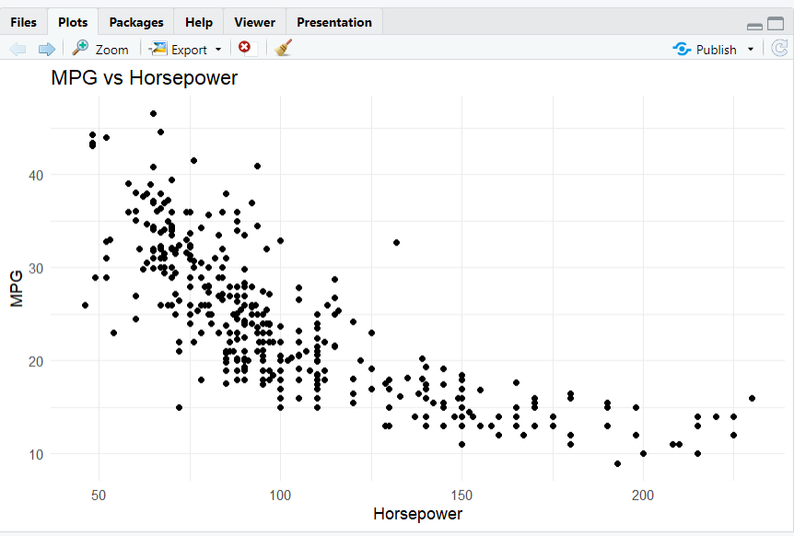
- This scatter plot shows the relationship between a car’s horsepower (x-axis) and its fuel efficiency, measured in miles per gallon or MPG (y-axis).
- Each dot represents a car from our dataset of 398 vehicles.
- The key pattern here is a clear negative correlation: as horsepower increases, MPG generally decreases. In other words, cars with more powerful engines tend to be less fuel-efficient.
- For example, cars with lower horsepower-under 100-often achieve over 30 MPG. In contrast, cars above 150 horsepower rarely exceed 20 MPG.
- This trend is expected: higher horsepower means the engine uses more fuel to deliver greater performance, which reduces efficiency.
- This insight was confirmed through our simple linear regression analysis, where we found that horsepower alone explains a significant portion of the variability in MPG.
- Overall, this plot visually supports our finding that horsepower is a strong negative predictor of fuel efficiency, which guided our further modeling and analysis.

Scatter Plot: MPG vs Weight in R Studio
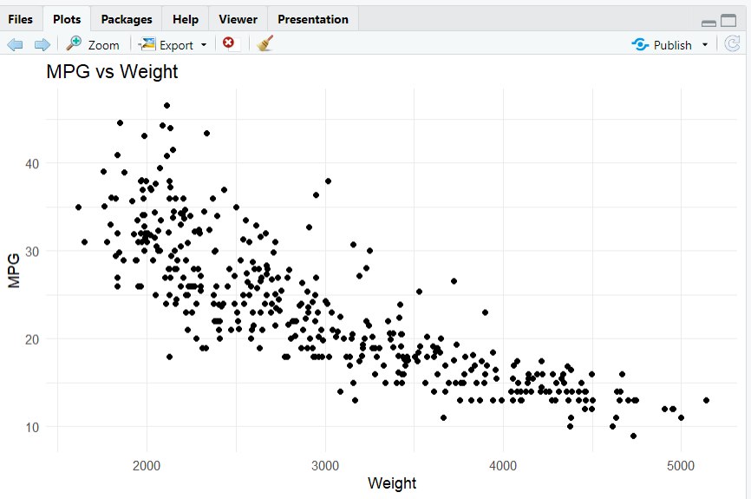
- This scatter plot shows the relationship between a car’s weight (x-axis) and its fuel efficiency, measured in miles per gallon or MPG (y-axis).
- Each point represents a car from our dataset. The overall pattern reveals a strong negative correlation: as weight increases, MPG decreases.
- Heavier cars, especially those above 4000 pounds, typically achieve lower MPG-often below 20. In contrast, lighter cars under 2500 pounds frequently exceed 30 or even 40 MPG.
- This makes intuitive sense: heavier vehicles require more energy to move, so they consume more fuel and are less efficient.
- Among all features we explored, weight is one of the strongest predictors of fuel efficiency. This was confirmed in our regression analysis, where weight had a significant negative impact on MPG.
- In summary, the plot highlights that reducing vehicle weight is a key strategy for improving fuel efficiency, both for manufacturers and consumers. This insight, along with horsepower, guided our approach to building more accurate predictive models for MPG.

Box Plot: MPG vs Number of Cylinders in R Studio
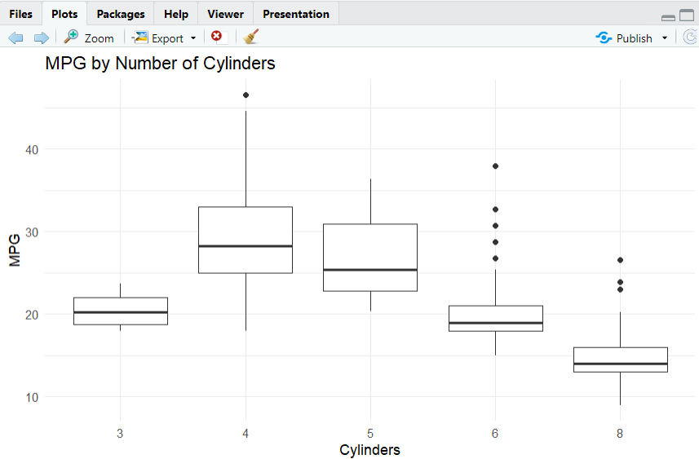
- This boxplot shows how fuel efficiency, measured in miles per gallon (MPG), varies with the number of engine cylinders in each car.
- Main Trend:
Cars with fewer cylinders-especially 4-cylinder engines-have much higher MPG. You can see the median MPG for 4-cylinder cars is the highest, and there are several very fuel-efficient outliers in this group.
- As the number of cylinders increases to 6 or 8, the median MPG drops significantly. 8-cylinder cars have the lowest MPG and the least variability.
- The spread in the 4-cylinder group is wider, showing a greater variety of models and fuel efficiency levels.
- Key takeaway:
Fewer cylinders generally mean better fuel efficiency. This supports the idea that smaller, simpler engines use less fuel.
- These results visually confirm that the number of cylinders is a strong predictor of MPG, which guided our further analysis and modeling.

To Conclude,
1. MPG vs Horsepower (Scatter Plot)
- The first plot shows MPG against horsepower for each car.
- There’s a clear negative trend: as horsepower increases, MPG decreases.
- This means cars with more powerful engines typically get lower fuel efficiency.
- For example, cars with horsepower below 100 often achieve over 30 MPG, while those above 150 horsepower rarely exceed 20 MPG.
- This supports our regression findings that horsepower is a strong negative predictor of MPG.
2. MPG vs Weight (Scatter Plot)
- The second plot displays MPG versus car weight.
- Again, we see a strong negative correlation: heavier cars tend to have much lower MPG.
- Lighter cars, under 2500 pounds, frequently achieve high fuel efficiency, while heavier cars, above 4000 pounds, often fall below 20 MPG.
- This suggests that reducing vehicle weight is a key strategy for improving fuel economy.
3. MPG by Number of Cylinders (Boxplot)
- The third plot is a boxplot showing MPG by the number of engine cylinders.
- Cars with fewer cylinders, like 4-cylinder engines, generally have much higher MPG.
- In contrast, cars with 6 or 8 cylinders have noticeably lower MPG, with more variability and outliers.
- This highlights that smaller, less complex engines are generally more fuel-efficient.
Summary:
Across all three plots, we see that lower horsepower, lower weight, and fewer cylinders are all associated with higher fuel efficiency. These insights guided our regression modeling and confirm that engine size and weight are key drivers of MPG. This evidence can help both manufacturers and consumers prioritize features that improve fuel economy.

Residual Plot using R Studio
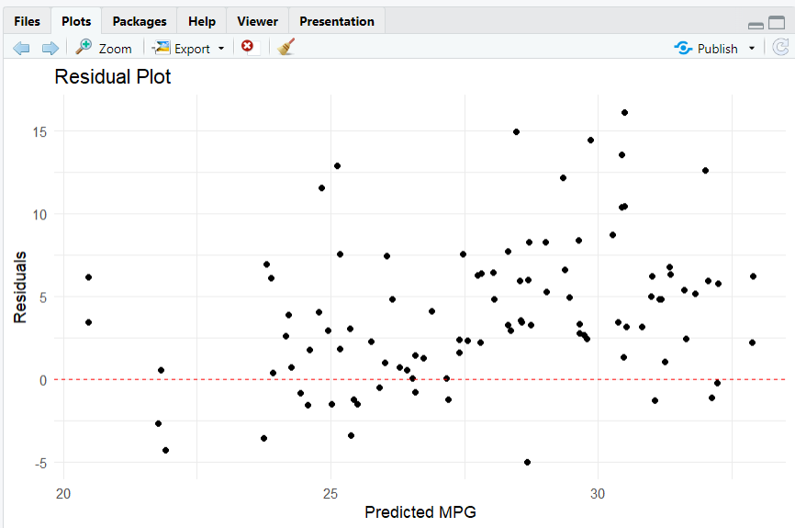
- This plot is called a residual plot. It shows the difference between the actual and predicted MPG values for each car in our test set.
- On the x-axis, we have the predicted MPG from our regression model. On the y-axis, we have the residuals, which are the errors or differences between the actual and predicted MPG.
- What to look for:
Ideally, residuals should be randomly scattered around the zero line, which is shown here as the dashed red line. This pattern means our model’s errors are unbiased and there’s no systematic pattern the model is missing.
- What we see:
  - Most points are clustered around zero, which is good.
  - There are some larger residuals, especially above the zero line, indicating a few cars where the model underestimates the actual MPG.
  - Importantly, there’s no obvious curve or trend, suggesting our model captures the main relationships in the data.
- Why this matters:
This plot helps us check if our regression model is appropriate. Since the residuals are fairly randomly spread, it confirms that our model is a reasonable fit for predicting MPG.
- Summary:
The residual plot gives us confidence that our model’s predictions are generally accurate, with only a few exceptions. This supports the reliability of our analysis and the conclusions we draw from it.

Histogram of Residuals using R Studio
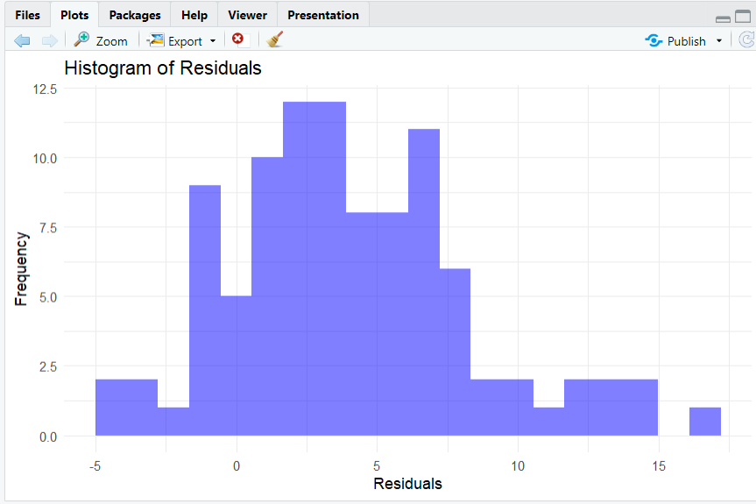
- This plot shows the distribution of residuals from our regression model.
Residuals are the differences between the actual and predicted MPG values for each car.
- Interpretation:
  - Most residuals are clustered between 0 and 10, meaning the model’s predictions are usually close to the actual values.
  - There are a few residuals below zero and some larger positive residuals, but the majority are positive, suggesting the model tends to slightly underestimate MPG for some cars.
  - The shape is roughly bell-shaped but slightly skewed to the right, indicating a few cases where the model under-predicts by a larger amount.
- Why this matters:
  - Ideally, residuals should be centered around zero, which would indicate no consistent bias in the model’s predictions.
  - The fact that most residuals are close to zero means our model is generally accurate, but the right skew suggests there are some outliers or specific cases where the model could be improved.
- Summary:
  - Overall, this histogram confirms that our regression model performs well for most cars, but there’s room to improve predictions for certain vehicles with higher residuals.

